Install Power BI Desktop and share the final screenshot of the report view page which appears when power desktop starts.

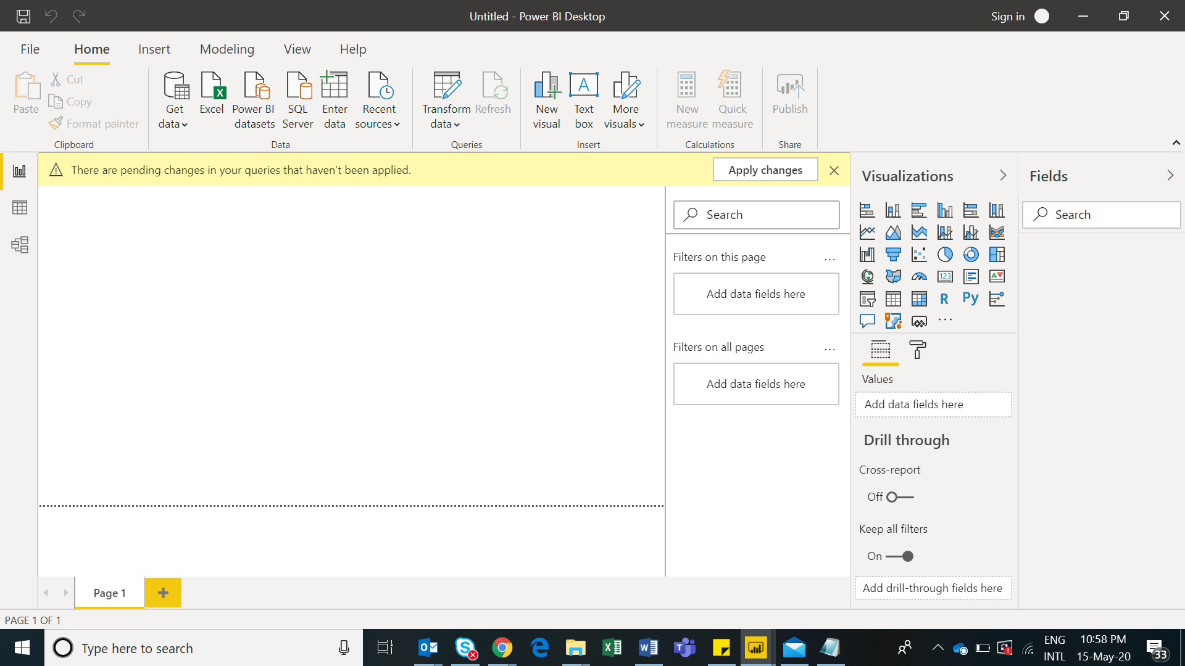

**Prepare a document and with the following screenshot**

**Report View Screenshot**

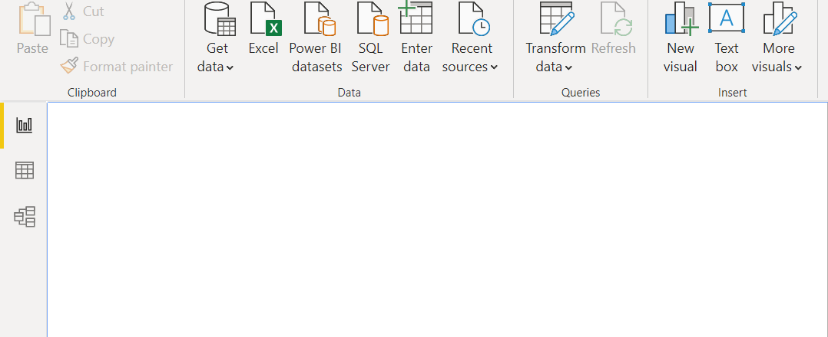

**Data View:**

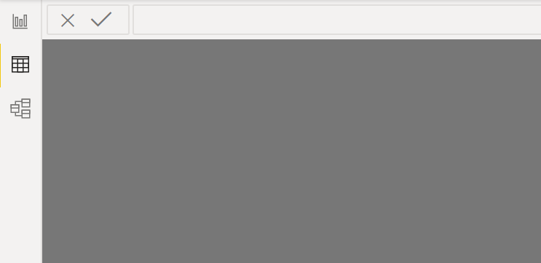

**Model View**

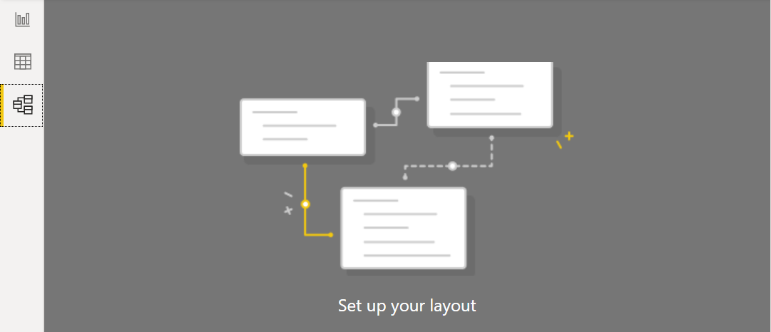

**Power Query Editor**

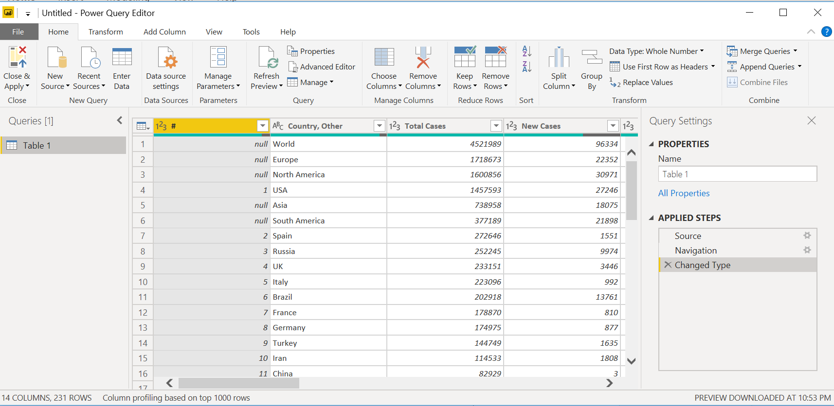

**Advance Editor**

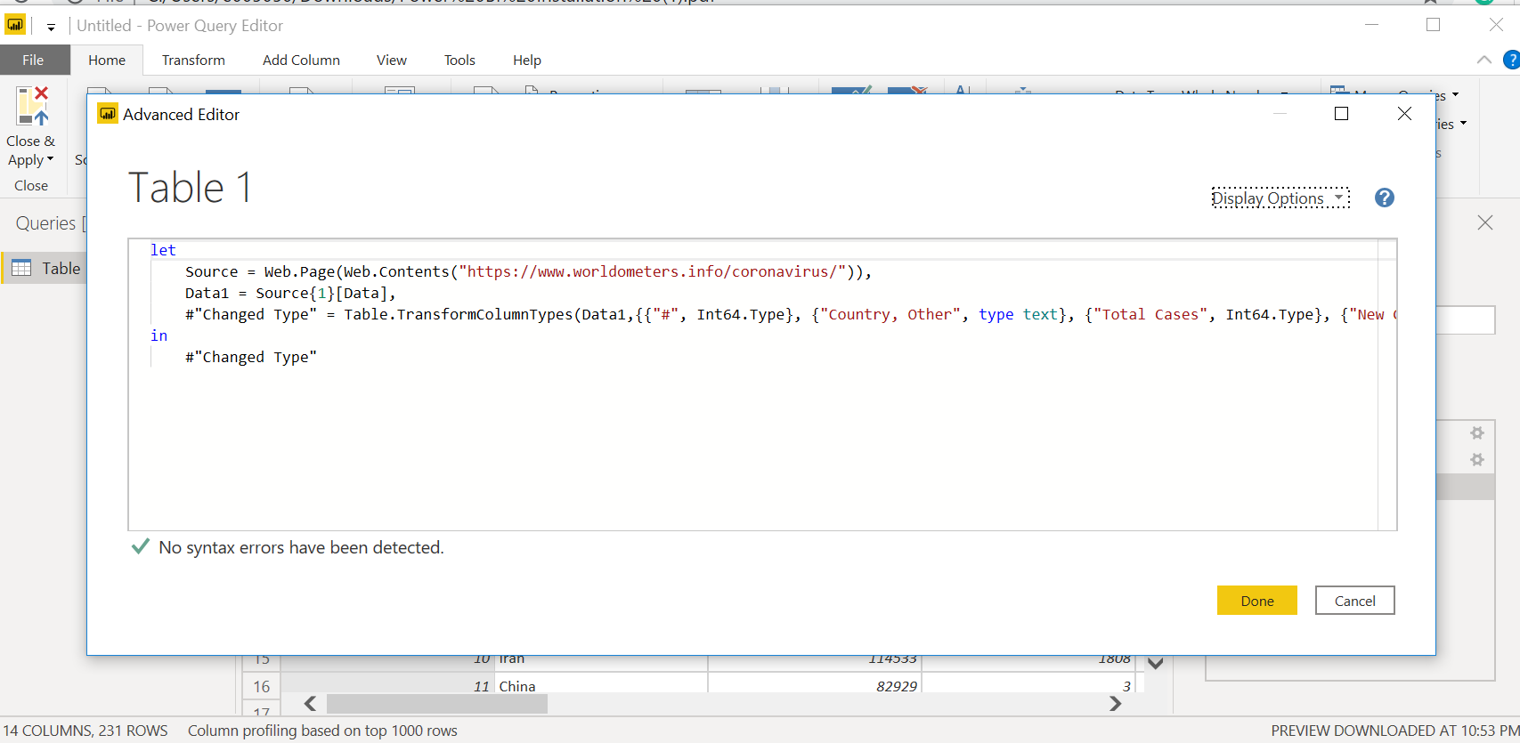

Prepare a document with details of the following along with their price

− Power BI Desktop – Free of cost

− Power BI Pro - Pro plan **costs** $9.99 per user per month

− Power BI Premium - The Premium plan starts at $4,995 a month per dedicated cloud compute and storage resource